

NORTHEASTERN UNIVERSITY

**COLLEGE OF ENGINEERING**

**INFO 6205 – Program Structures and Algorithms**

**Document Control**

|  |  |
| --- | --- |
| **Document Details** | |
| **Author** | **Anurag Parla** |
| **Author** | **Hiral Nagda** |
| **Author** | **Pranoti Dhabu** |
| **Title** | **MSD Radix sort for a natural language using unicode characters** |

|  |  |  |  |
| --- | --- | --- | --- |
| **Version and Distribution History** | | | |
| **Version #** | **Date** | **Description of Change** | **Author** |
| **1.0** | 12/04/2021 | **Initial Draft** | **Pranoti Dhabu** |

**Document Approvals**

|  |  |  |  |
| --- | --- | --- | --- |
| **Name** | **Title** | **Signature** | **Date** |
| **Prof. Robin Hillyard** | **Associate Professor** |  |  |

# Contents

Table of Contents

Contents 3

Solution Overview 4

Summary 4

MSD Radix sort 4

Background 4

Experiment 4

Assumptions 4

Challenges 5

Running our experiment 5

Conclusions from the experiment 5

Observations 5

Conclusion 8

Unit Tests 8

Appendix – A – References 11

# Solution Overview

This solution implements sorting of strings of any natural language using Unicode characters and benchmarks the performance of various algorithms for a comparative study.

## Summary

The main purpose of this solution is to implement Unicode encoding of strings and perform sorting using MSD radix sort, LSD radix sort, dual pivot quick sort, husky sort and timsort. Followed by benchmarking on a natural language with a data set up to 4M records.

# MSD Radix sort

MSD Radix sort is a key-indexed counting sorting algorithm majorly used for sorting strings. The algorithm essentially creates a partition for each character of the sort-key while traversing from left to right and this method of sorting is applied to each partition recursively.

## Background

Strings are used as the sort key in majority of applications and hence new algorithms were being researched and developed for effective and fast sorting to lower the time complexity. LSD and MSD Radix sort algorithms were developed looking at these constraints. Key-indexed sorting methodology has three main components – computing frequency counts, converting counts to indices and distributing the data.

As part of this project, we have modified algorithms proven to be efficient to sort natural language words based on Unicode value. We consider MSD radix sort, LSD sort, dual pivot quick sort, timsort and husky sort algorithm to compare their time complexity.

# Experiment

In our experiment we have used primarily used Devanagari script (for Hindi language) as the natural language for sorting. Before benchmarking for Hindi language, we first established confidence by sorting English words and then proceeded towards native languages like Hindi, Gujarati (Sanskrit script) and simplified Chinese using collators for respective languages.

Further we benchmarked the five sorting algorithms for data set varying from size 1000 to 4M by doubling method.

We have re-used code from the class repository as well as Husky sort repository and made the necessary modifications for passing collator object as well Unicode conversion.

## Assumptions

Following are the assumptions for our experiment:

1. The data set (corpus) is a partially random list of words. The corpus contains approx. 40k unique words which were increased to 4M.
2. All experiments are performed on M1 MacBook Air machine. Any machine dependent factors determining running time will be common across all runs. (It was ensured the runs were performed on a fully charged and plugged-in machine with no applications open).

## Challenges

Throughout the progress of our project, we came across below challenges:

1. We found difficulties in getting a clean corpus of Hindi words. While we tried cleaning up the data by writing small python scripts, not all corpus was cleaned. Hence, we decided to repeat the corpus of 40k words and increased it to 4M by duplicating words. Thus, the data set is partially random array of repeating sequences.
2. During benchmarking, since we are also timing pre-processing i.e., Unicode conversion the initial run for sorting 1k words took approx. 850ms for MSD Radix sort. After further analysis, it was observed the logic we used for array creation also included reading the file contents from disk which accounted for large run time. We decided to cache the same and the run time was reduced considerably to 9ms.

## Running our experiment

We implemented benchmark java files for all the 5 sorting algorithms and ran the benchmark for data set varying from 1k to 4M.

Benchmarking numbers obtained are an average taken over 10 runs.

## Conclusions from the experiment

We can derive the following conclusions from our experiments.

1. Time taken to sort the array of strings is directly proportional to the size of array and doubles as the input array size doubles.
2. Apart from dual pivot quick sort, all algorithms show a linearithmic growth graph.
3. We noticed log-log plot for MSD radix flattens after array size increases beyond 1M.
4. Log log plot indicates timsort, husky sort and LSD radix sort are converging as array size increases. Per the implementation of husky sort, as number of comparisons are less it is more efficient.

So, what these experiments mean,

1. Husky sort has proven to be the most efficient algorithm for string sorting closely followed by timsort, LSD radix sort and MSD radix sort when input size is considerably large (over 1M).
2. For small size input, timsort is more efficient sorting algorithm.

# Observations

The following observations were noted by our benchmarking runs.

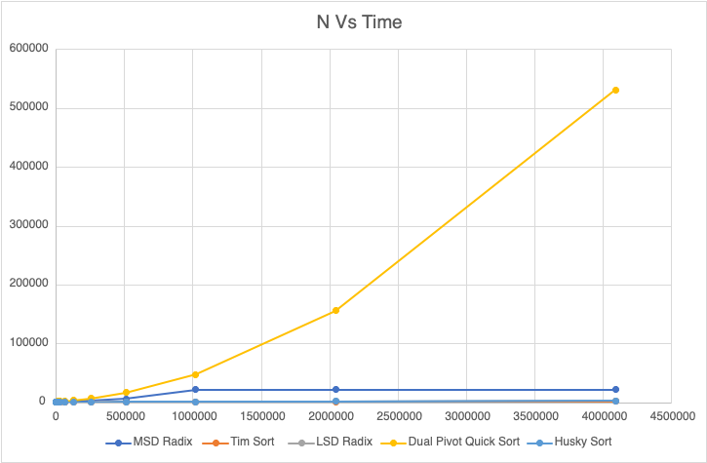

|  |  |  |  |  |  |
| --- | --- | --- | --- | --- | --- |
| Input Size | MSD Radix | Tim Sort | LSD Radix | Dual Pivot Quick Sort | Husky Sort |
| 1000 | 9.6 | 0.21 | 3.46 | 25 | 0.55 |
| 2000 | 13.8 | 0.36 | 2.53 | 54.4 | 1.32 |
| 4000 | 28.9 | 0.36 | 2.68 | 121.8 | 2.31 |
| 8000 | 47.8 | 0.92 | 3.48 | 590 | 5.23 |
| 16000 | 96.1 | 1.58 | 5.11 | 1456.2 | 6.25 |
| 32000 | 196 | 3.3 | 10.2 | 1662.6 | 8.81 |
| 64000 | 493.2 | 9.86 | 18.22 | 1427.1 | 17.12 |
| 128000 | 1139.9 | 27.15 | 38.83 | 2919.4 | 40.62 |
| 256000 | 2639.8 | 67.5 | 90 | 6387.2 | 87.12 |
| 512000 | 5266.1 | 169.74 | 314.2 | 16549.2 | 238.11 |
| 1024000 | 21085.1 | 380.49 | 645.98 | 47029.8 | 480.24 |
| 2048000 | 21306.8 | 832.76 | 1288.6 | 155186 | 1078.07 |
| 4096000 | 21581.3 | 1739.78 | 2572.97 | 531048 | 2144.79 |

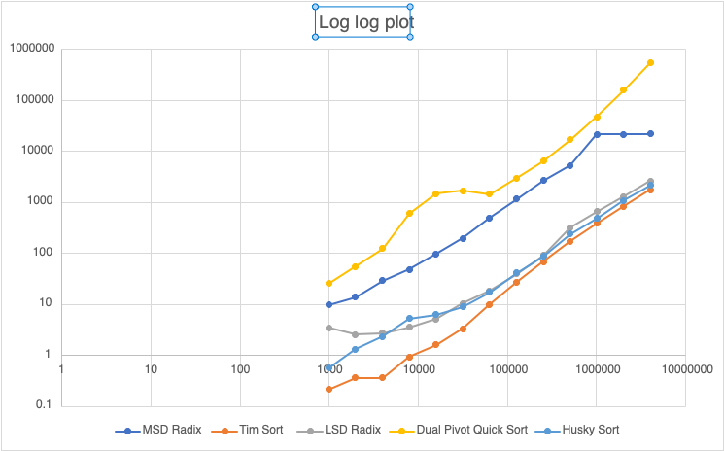

## Conclusion

As demonstrated in the previous section, it is evident that dual pivot quick sort is not effective for sorting strings. Husky sort, MSD radix sort, timsort and LSD radix sort are proven to be efficient as per the benchmarking runs and graphs plotted.

# Unit Tests

The following unit tests will demonstrate the validity of our experiments.

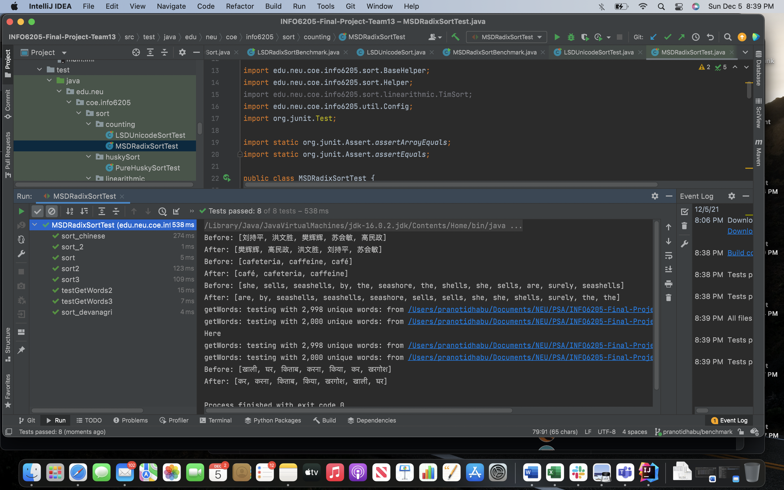

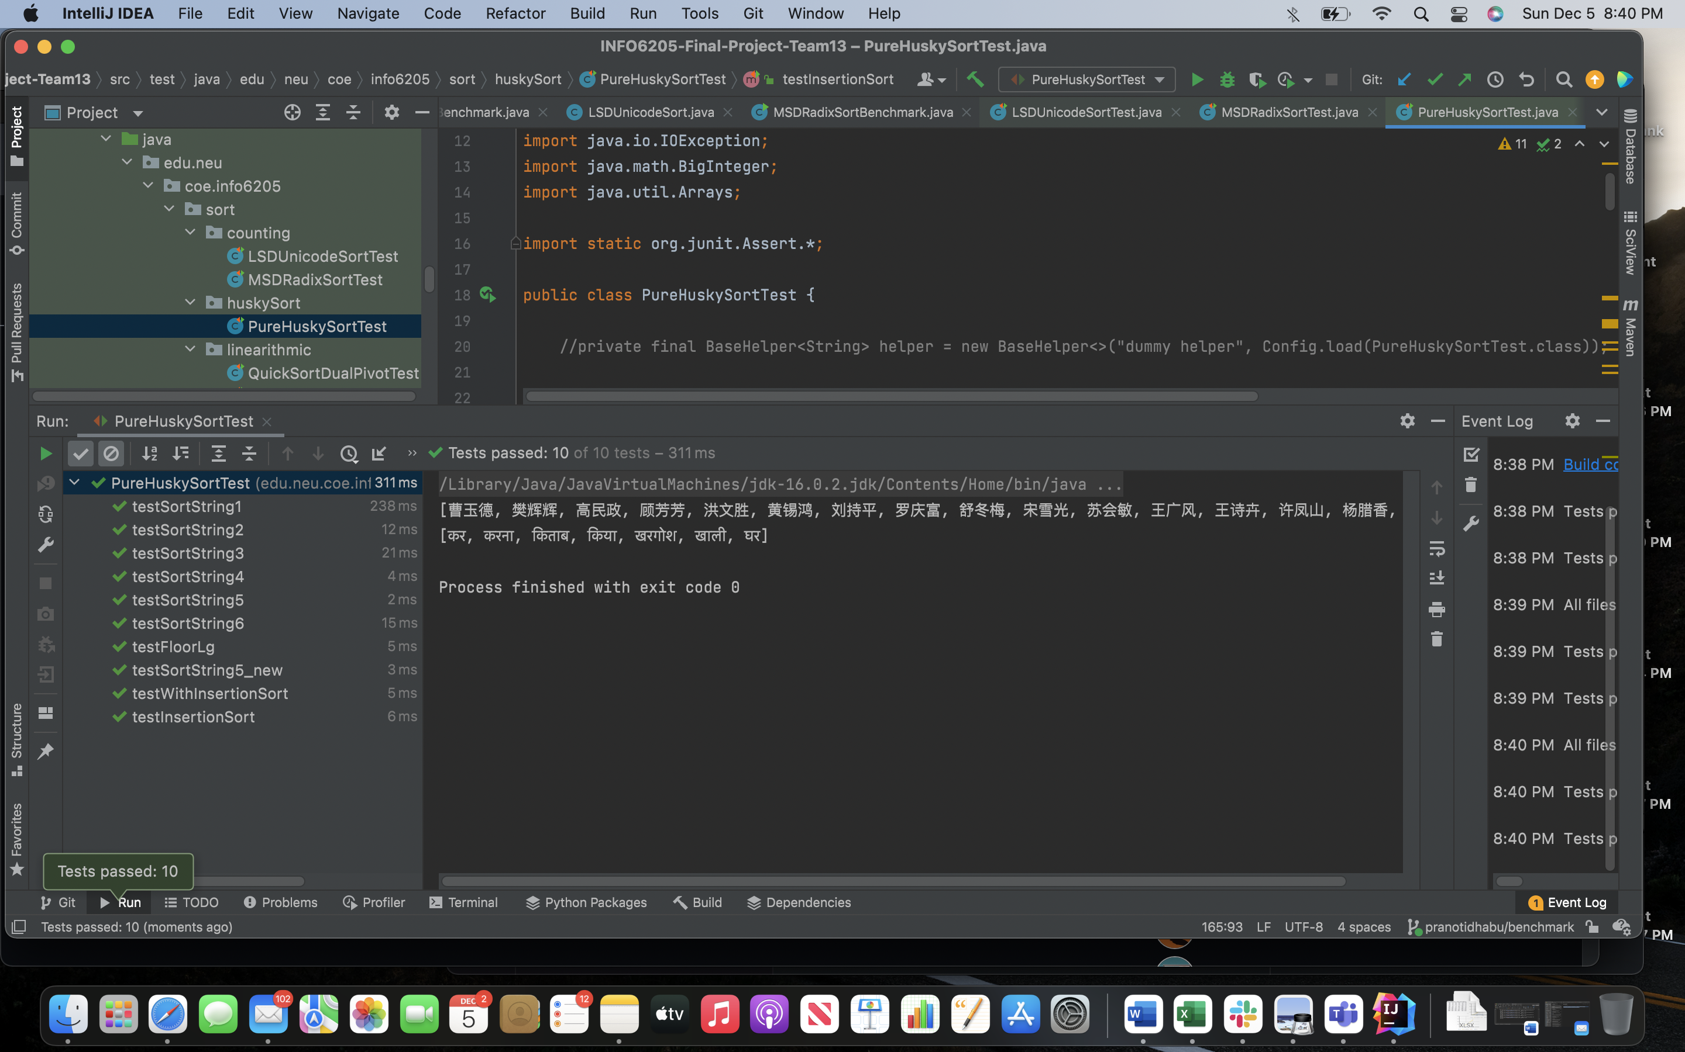





# Appendix – A – References

|  |  |
| --- | --- |
| **Titles** | **Description/Link** |
| Husky sort repo | https://github.com/rchillyard/The-repository-formerly-known-as |
| Class repo | https://github.com/rchillyard/INFO6205 |
| Hindi corpus | https://wortschatz.uni-leipzig.de/en/download/Hindi |
| Textbook  (for code references) | *Algorithms*, 4th Edition by Robert Sedgewick and Kevin Wayne, Addison-Wesley Professional, 2011, ISBN 9780321573513 |